
MORNING STAR SCHOOL
ACADEMIC SESSION 2024-25
SUMMER HOLIDAY HOMEWORK
Class-XII (Hum.)
GENERAL INSTRUCTIONS
⭐The assignment should be done as per the instructions given.
⭐It should be neatly labelled with your name, class and section mentioned clearly.
⭐The last date of submission of holiday assignment is 5thJuly 2024.
⭐Students are requested to do a lot of reading of books related to their stream & newspapers.
⭐ Prepare yourself for the Periodic Test-I which is going to be held in the month of July.
Holiday homework is intended to make students independent and enhance their skills and capabilities. Holiday homework helps to keep students on track and keep their brains ticking.

Subject:-ENGLISH
Give a thorough revision of the lesson 'The Last Lesson' (Flamingo)
Solve the following in your Grammar registers:
Advertisement
1.Orient Girls Hostel, GK-1,New Delhi needs the service of a warden. Draft an advertisement for publication in a local daily asking deserving candidates to appear for a walk-in-interview on 5 & 6 June from 9am to 1pm at B-38 (Ground Floor) Safadarjung Enclave, New Belhi.
2.You are the Manager, Infocom Network, C- B Main Shopping Center, Vasant Vihar, New Delhi. Draft an advertisement offering office furniture for sale. Give necessary details.
Notice
1. You are President of the Cultural Society of your school. You are planning to organize a cultural programme . Write a notice for the school notice board inviting names of students willing to participate. You are Sudhir, the secretary of the society.
2. Write a notice for your school notice board in 50 words inviting articles for your school magazine. You are Ramesh , student Editor of your school.
Poster Making
1.Design a poster in not more than 50 words about the need for regular exercise. You may use slogans.
2. Design a poster for promoting kindness towards animals.
Letter
1. You have received an invitation from your aunt at Manila to spend some days during your summer vacation with her. Respond to this invitation. You are Madhav/ Manisha, of 27, Patel Nagar, New Delhi.
Article Writing
You think differently from the way your parents think about food, clothing and lifestyle. Write an article on 'Generation Gap- A Myth or Reality ' in about 150-200 words.

Subject:-HISTORY
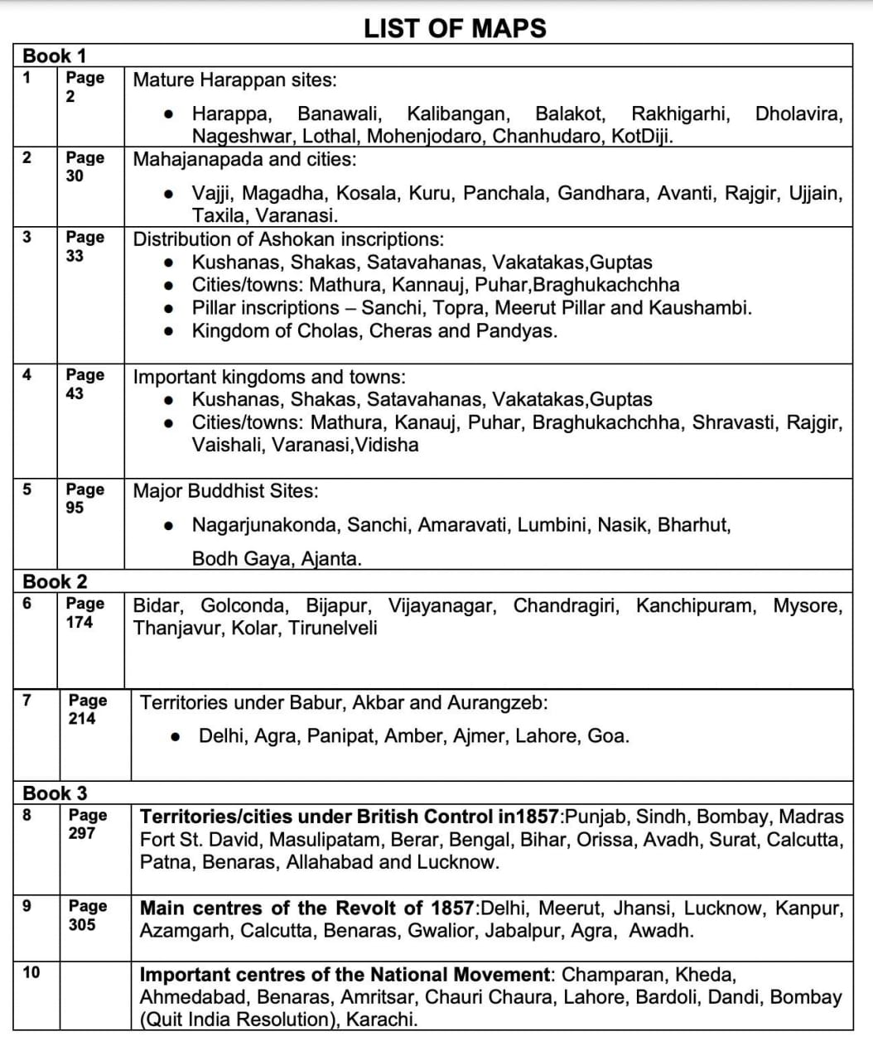

Subject:-POLITICAL SCIENCE
- Project File On -
- a - Shock Therapy
- b - Bricks
Subject:-GEOGRAPHY
1. Discuss the factor responsible for uneven distribution of population in India.
2. Explain the trend of population growth in India since 1901.
3. Prepare a dot map showing the distribution of India's population.
4. Compare the growth rate of population of different states between 1991-2001 and 2001-2011.
Subject:-ECONOMICS
1. What is macroeconomics? Explain scope and significance of macroeconomics.
2. Explain the followings-
a. Durable Goods
b. Semi Durable Goods
c. Non-Durable Goods
d. Non-Material goods and services
3. Difference between final goods and intermediate goods
Subject:-HINDI
1.हिंदी साहित्य में ऋतुओं का सचित्र वर्णन कीजिए।
2.प्रेमचंद की रचनाओं का सचित्र वर्णन कीजिए।
3.समाचार व पत्रकारिता में अंतर बताइये तथा समाचार की एक रिपोर्ट तैयार कीजिए।
(किसी एक विषय पर परियोजना कार्य करना है।)

Subject:-PHYSICAL EDUCATION
1. Explain the. Procedure of giving bye in fixture.
2. Draw a league fixture for 16 teams
3. Draw a knockout come league fixture of 16 teams.

Subject:- COMPUTER
- Write 20 Python program based on revision of class 11 python
- Make a presentation on cyber security
- Make presentation on cyber ethics
*ACTIVITY RECOMMENDED DURING VACATION*
- Meditate and do simple yoga exercises .
- Water plants and feed the birds.
- Join your grandparents and parents for their morning walk.
- Help your mother in the kitchen .
- Don’t watch too much of television .
- keep your environment in surrounding clean .
- Plant trees and conserve your natural resources.
- Build and improve your vocabulary through crosswords, jumble words etc.
- Solve riddles and puzzles.
- Read story books and visit places.
- Improve your reading and writing skills by reading and writing.
Note:
- Summer breaks are from 5th May to 23 June 2024. The school will
reopens on 24th June 2024

Have a great
Summer Vacation

- * POLITICAL SCIENCE

- * GEOGRAPHY

- * ECONOMICS

- * हिंदी
- * PHYSICAL EDUCATION
- 1.

